**PROJECT MODELLING APPROACH STUDY REPORT**

**Course : Software Engineering - CS301**

**INSTITUTE NAME : INDIAN INSTITUTE OF INFORMATION TECHNOLOGY, DHARWAD (IIITDWD)**

**NAME : CHATURTH R  
ROLL NO. : 21BCS025 , 4TH SEM CSE SEC ‘A’**

**GITHUB PROFILE -** [**https://github.com/Chaturth-R**](https://github.com/Chaturth-R)

**PROJECT NAME :** A weather app that utilizes a weather API to display current and forecasted weather information.

**APP NAME : ANEGUDDE WEATHER APP**

**TEAM NAME : ANEGUDDE WEATHER APP**

**OBJECTIVE :**

* **To perform the Requirement elicitation process in detail using modelling approaches .**
* **Learn Use case, Class and Sequence diagram implementation through Experiential learning of a Software engineering course project .**

**A. DRAW USE CASE DIAGRAM :**

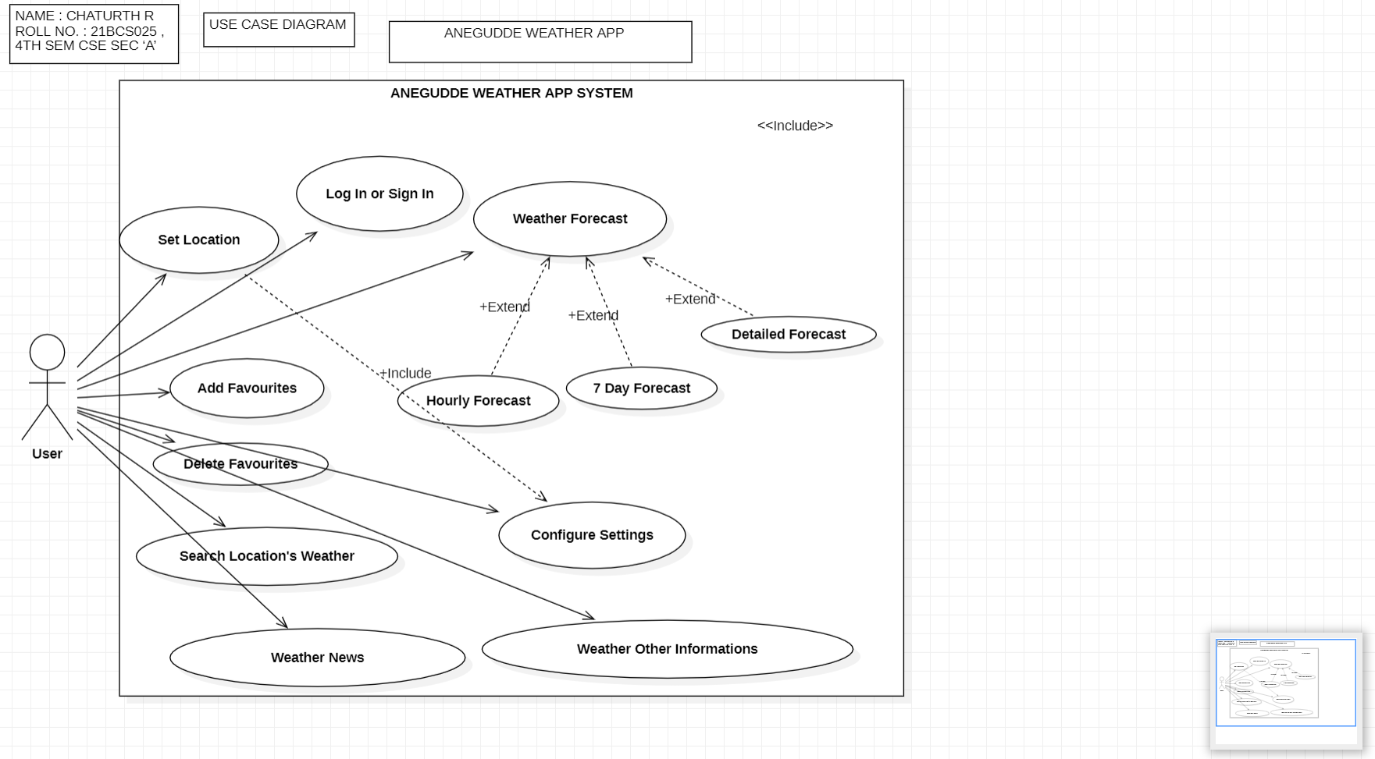

**B. DRAW CLASS DIAGRAM :**

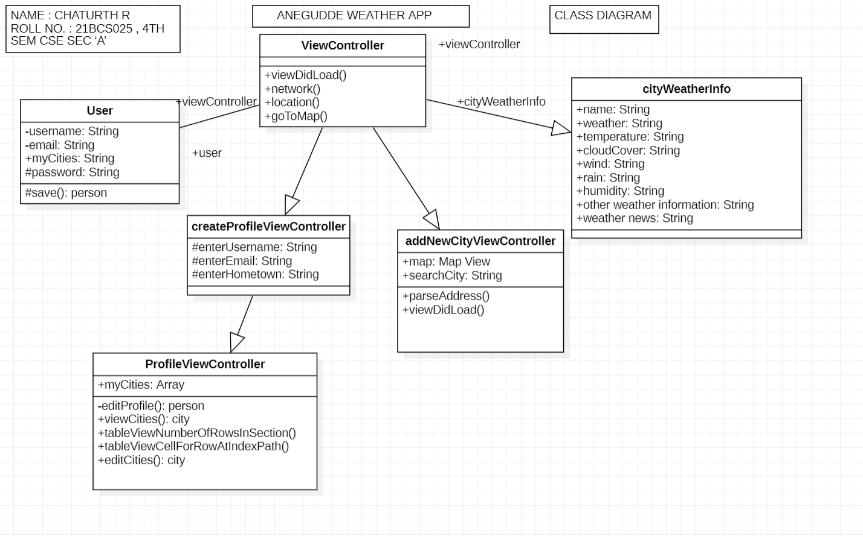

**C. DRAW SEQUENCE DIAGRAM :**

**SEQUENCE DIAGRAM PART-1 :**

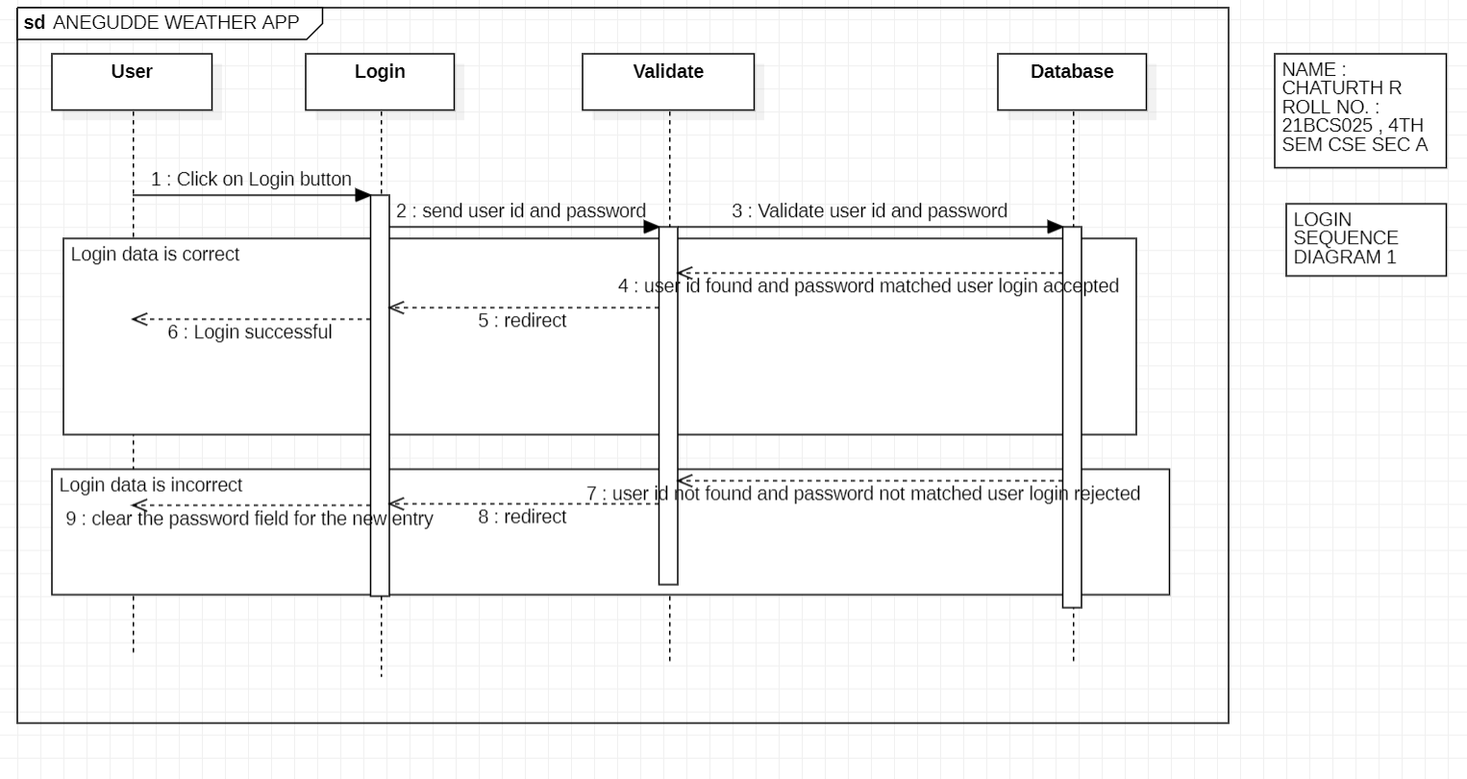

**SEQUENCE DIAGRAM PART-2 :**

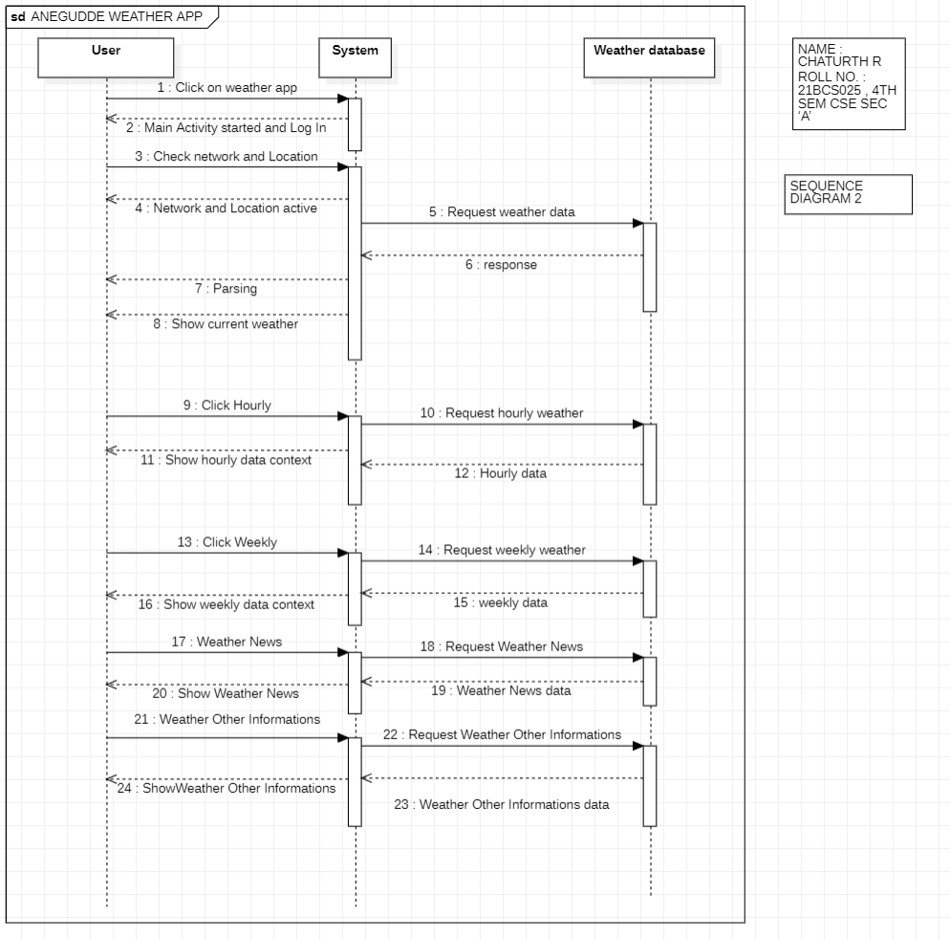

**D. Used the StarUML tool for drawing the diagrams.**